**1.SUM OF ELEMENTS IN AN ARRAY**

<!DOCTYPE html>

<html>

<head>

<title>ARRAY</title>

</head>

<body>

<h1>SUM OF ELEMENTS IN AN ARRAY</h1>

<script type="text/javascript">

function Sum(no)

{

var sum=0;

for(i=0;i<no.length;i++)

{

sum=sum+no[i];

}

console.log("sum is" ,sum);

}

data=[10,20,45,55,66];

Sum(data);

</script>

</body>

</html>

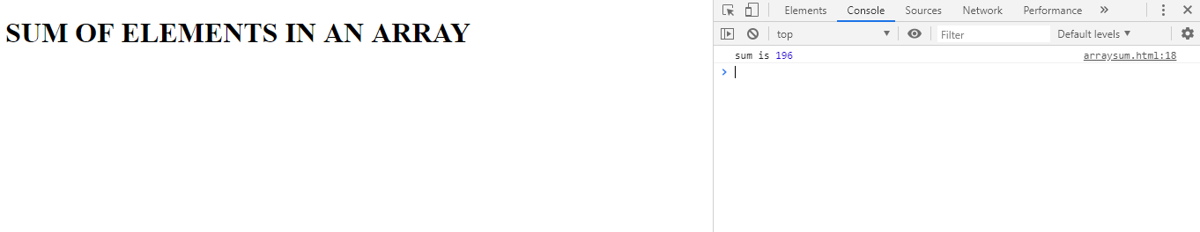

**2.AVERAGE OF ELEMENTS IN AN ARRAY**

<!DOCTYPE html>

<html>

<head>

<title>ARRAY</title>

</head>

<body>

<h1>SUM OF ELEMENTS IN AN ARRAY</h1>

<script type="text/javascript">

function Sum(no)

{

var sum=0;

for(i=0;i<no.length;i++)

{

sum=sum+no[i];

}

console.log("sum is" ,sum);

}

data=[10,20,45,55,66];

Sum(data);

</script>

</body>

</html>

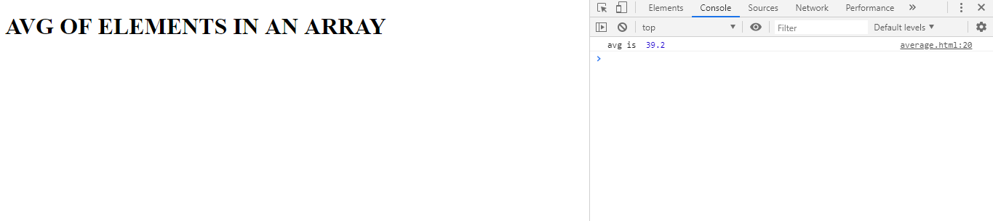

**3.MAXIMUM ELEMENT IN AN ARRAY**

<!DOCTYPE html>

<html>

<head>

<title>ARRAY</title>

</head>

<body>

<h1>MAX ELEMENT IN AN ARRAY</h1>

<script type="text/javascript">

function maxofarray(no)

{var max=0;

var l=no.length;

for(i=0;i<l;i++)

{

if(no[i]>max)

{

max=no[i];

}

}

console.log("max is" ,max );

}

data=[10,500,45,55,4567];

maxofarray(data);

</script>

</body>

</html>

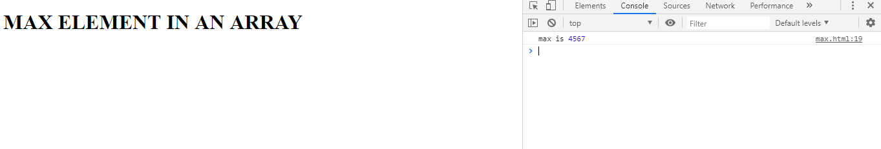

**4.SEARCH AN ELEMENT IN AN ARRAY**

<!DOCTYPE html>

<html>

<head>

<title>search</title>

</head>

<body style="background-color: #aaa">

<h1>Searching...</h1>

<script type="text/javascript">

function SearchElement(no,key)

{

var res;

var l=no.length;

for(i=0;i<l;i++)

{

if (no[i]==key)

{

return true;

break;

}

}

}

var data=[10,500,45,55,4567];

var key=50;

if(SearchElement(data,key))

{

console.log('The number '+ key +' is present is an array') ;

}

else

{

console.log("The number "+ key+" is not present in an array");

}

</script>

</body>

</html>

